

Graduate Diploma in Software Engineering

Hotel Calamander Unawatuna Beach Resort

Student Name :- Geeth malinda

Batch:- 54

NIC :- 200009203082

Submission Date:-2020/03/06

**Content**

**No Title Page No**

1.0 Introduction to Business 3-5

1.0.1 History 5

1.2 Employee Hierarchy 6

1.3 Business Process 7

2.0 IT Solution 7

2.1 Identify Issues 7

2.2 Suggestions 8

2.3 Hardware requirement 8

3.0 Use case Diagram 9

4.0 Entity relationship Diagram 10

**List if figures**

**No Title Page no**

1.2.0 Employee hierarchy 6

3.0.0 Use case Diagram 9

4.0.0 Entity relationship Diagram 10

**List of Abbreviations**

* IJSE – Institute of Java & Software Engineering
* IT – Information Technology
* RAM – Random Access Memory
* GB – Giga Byte
* UBR – Unavatuna Beach Resort

**1.0 Introduction to Business**

**Location**

**Beachside location off the corner of the Unawatuna strip**

Calamdander Unawatuna Beach’s location is ideal – it’s close enough to the main action to be walkable, but just remote enough, set in a corner, to give a little respite from the hubbub. Plus, with over 430 feet of beach at its back, it’s got one of the largest (and cleanest) sandy backyards in the area. The resort is under a five-minute walk to the main Matara Road, an eight-minute drive to the Japanese Peace Pagoda, and a four-minute drive to the Unawatuna rail stop. Bandaranaike International Airport is just two hours’ drive north. Popular tourist spots are within driving distance: it’s one hour and 50 minutes to the capital city of Colombo, 15 minutes to the historic city of Galle and its fort, one hour to the relaxing lakeside town of Bentota, and 40 minutes to the surfer beaches of Hikkaduwa.

**Rooms**

**Simple and contemporary Western-style rooms and amenities**

All of Calamander Unawatuna’s 83 rooms were given updates – or just being built – between 2011 and 2015. Standard rooms in the Deluxe category include convenient features such as tea/coffee facilities, minibars stocked with snacks and drinks, flat-screen TVs with satellite channels, laptop-size safes, personal outdoor space, rainfall showers, makeup mirrors, and toiletries, including shampoo plus conditioner bottles. The contemporary decor is standard through all categories and consists of dark brown, IKEA-style furniture with a mid-century flair, bright pops of color in fabrics and decor accents, and fully tiled bathrooms. Super Deluxe Rooms offer slightly more space and additional sitting areas with folding sofa beds. The newest rooms in the bunch are the Luxury Rooms, which are huge, with all the features of Super Deluxe Rooms, plus large jetted bathtubs in the bathrooms, two bathrobes and slippers, rain umbrellas, and enough space in each to sleep a family of four. All rooms have hairdryers, free bottled water daily (two per day in Deluxe Rooms; three per day in Luxury Rooms), and Wi-Fi.

**All-Inclusive / Food**

**Unawatuna’s largest dining room with two restaurants and ocean views**

Dining selections at the resort include a large, open-air main restaurant called Melt where guests can have either a big and tasty buffet or a la carte menu, both with local and international cuisine – including Sri Lankan comfort foods and all-day English breakfasts – and an international wine list. While breakfast is free, guests have the option of upgrading to a half-board or full-board meal plan, though no all-inclusive plan exists. There’s also a small spot designed like a brick oven pizzeria, called Brix, which shares the same roof as Melt but has lighter cafe-style dishes and made-to-order, brick oven pizzas.

**Drinks**

**Two bar areas, including a sports-themed beach bar with social vibe**

If guests want drinks outside of the restaurant, they’ll have to head over to one of the resort’s two bars. Both spots, just across a small bit of sand from one another, are open-air joints with daily specials, ocean views, and outdoor deck seating. Attached to the back of the Brix oven, there’s a small bar with cushy seating, board games, and full bar, plus lots of extra outdoor deck seating. This spot has more of a lounge vibe, while just across the sand, 680 Blu Bar serves the majority of guests either at the blue-lit bar, out on the deck, or at high tops on the sand. With a heavy sports theme, this bar has a casual beach bar atmosphere and a mean happy hour cocktail list.

**Features**

**Two pools, swimmable beach, and places to play or relax**

Calamander Unawatuna Beach is blessed with a fair amount of space – not even counting the large beachfront backyard. While several Unawatuna spots can lay claim to their own sections of beach, Calamander’s 433-foot stretch is undoubtably the largest. It also has some of the calmest waters, meaning unlike several areas that seem to have red flags flying all the time, especially during monsoon season, guests at Calamander can usually, actually go in the water. The resort also says that lucky guests may even spot a sea turtle swimming around.

Aside from having an unparalleled bit of beach, Calamander is also the only beachfront property in Unawatuna to sport a pool. This narrow lap-style pool is over 80 feet long with a full glass front. It’s the first of its kind in Sri Lanka and the longest glass-fronted lap pool in the Asia-Pacific region. After the 2015 renovations in the new wing, the resort added a second pool, complete with Unawatuna’s only hot tub and a paddle pool section for kids. This wing is also where guests can peep the huge Italian mural completed in late 2015.

Activities include a selection of international and local board games, beach volleyball, a watersports center with kayaks and boogey boards, a PADI-certificed dive center, and a small fitness room with weights, machines, and yoga facilities. There’s also a small wellness spa on-site for beauty treatments and massages.

Kid-friendly features include the area’s only kids’ club, an assortment of games and activities for kids, a dedicated kids paddle pool, and larger capacity Luxury Rooms for families.

The resort has free Wi-Fi throughout the property and is handicapped accessible.

**1.0.1History**

* One of Sri Lanka's first beach hotels, and known then as Unawatuna Beach Resort or UBR, this resort first opened its doors in 1982. After extensive revamping, updating, and a bit of renovations -- which included the huge Italian mosaic, an additional pool with kiddy pool and hot tub, and a collection of new Luxury Rooms -- found in a new wing, the resort has rebranded itself as Calamander Unawatuna Beach. However, at least while the process is still underway, remnants of UBR can still be seen on the padded sun lounger cushions, umbrellas, and a few other small details.

**1.2Employee Hierarchy**

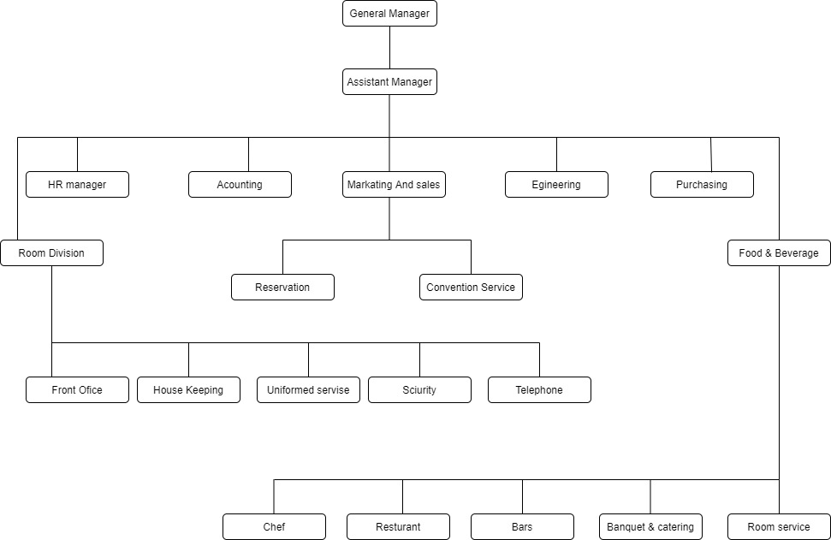

**1.3 Business Process**

* Customer can make an order and request items for their requirement.
* Employee checks the requested item and that can be available

In their item stock.

* If items are available in item stock then employee place that order

According to customer preference.

* Then Employee can be able to give some discount for the customer.
* Then Employee checks the available free tables for that customer.
* Finally Employee could be able to generate the invoice for that order.
* When customer have done his job then employee take the responsibility to free that customer table.

**2.0 IT Solution**

I am going to give a IT solution for manual process of Restaurant food Ordering sales side of UBR.

**2.1 Identified Issues**

* The manual Order receiving process is difficult.
* Low security of financial transactions.
* Difficult to manage tables.
* Difficult to manage Employees.
* Time consuming is very high for process Order.
* Can’t generate the reports easily.
* Difficult to manage Items.

**2.2 Suggestions**

* We can enter the all item details and it will help to

add ,delete ,update item for order.

* All the payments will be much easier and correct when we’re doing it through the system.
* We can select free tables in low time consuming .
* System can view the orders history and order details.
* All the item details and other details can store in

System much easily.

**2.3** **Hardware Requirements**

* 2 Personal Computers with,
  + Monitor ( 1600*900 resolution )
  + 1TB Hard disc.
  + 8GB RAM.
  + 1GB VGA card.
  + Core i5 processor.
* printer
* Scanner.
* Barcode Reader.
* Wi-Fi or 4G Route

3.0 **Use Case Diagram**

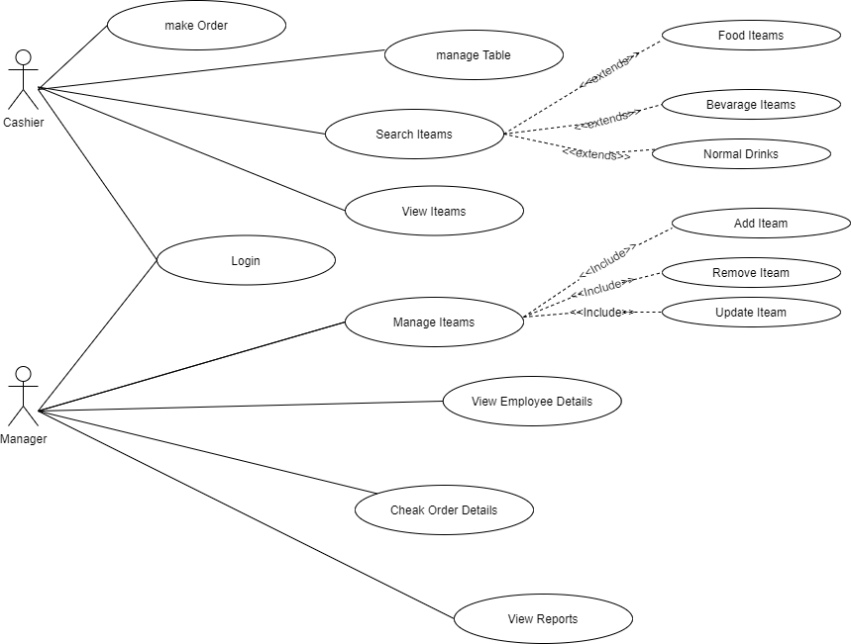

**4.0 Entity Relationship Diagram**

